CONGRATULATIONS TO THE CAST OF
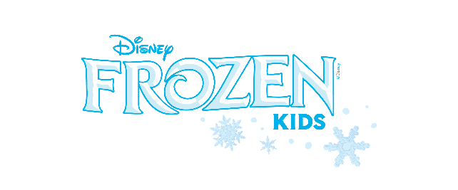
Saturday Cast Arendelle
Sunday Cast Northuldra (Queen Home – Frozen 2)

Young Anna Pg 1-4/ Off Snow/Summer Claire Lindsey
Middle Anna Pg 5-16/ Townsperson Hannah Miller
Anna / Off Snow/Summer Dance Captain Brynn Pelger (Sat) Liz Firestone (Sun)
Young Elsa Pg 1-4/ Off Snow/Summer Elizabeth Durfee
Middle Elsa Pg 5-16/ Townsperson Elliana Lindsey
Elsa /Off Snow/ Summer Dance Captain Emily Schwab (Sat) Skyler Smith (Sun)
Snow Chorus / Summer Chorus Serena Ramirez, Leah Crawford, Sadie Laverick
Olaf/ Off Summer Chorus Layla Gillespie (Sat) / Mia Colston (Sun)
Kristoff Luca Chavez
Sven Caleb Chavez
Hans Avishai Hinterleiter
Weselton, Townsperson, Hidden Folk - Noah Fisher
King Agnarr/ Hidden Folk Corben Annerino
Queen Iduna/ Hidden Folk Elia Joseph
Townspeople 1 & 3 / Hidden Folk – Peyton Liddle
Townspeople 2 & 4/ Hidden Folk Evelyn Billings
Steward / Bulda Sophia Fout
Bishop / Pabbie Vincent Davenport
Story Tellers/ Featured Soloists Hannah Smith, Ruby Harvey, Sidney Merrell
Cook - Hannah | Housekeeper - Ruby | Handmaiden/Butler - Sidney

